1. Customer Information (Individual)

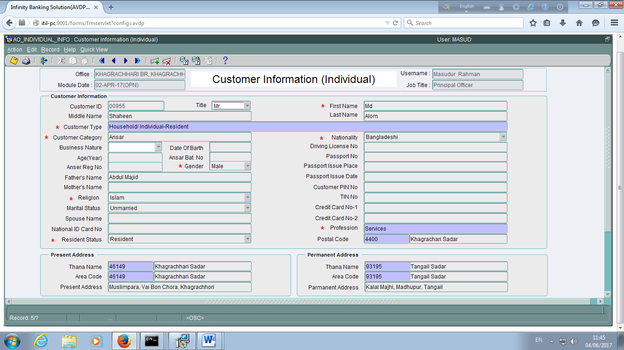

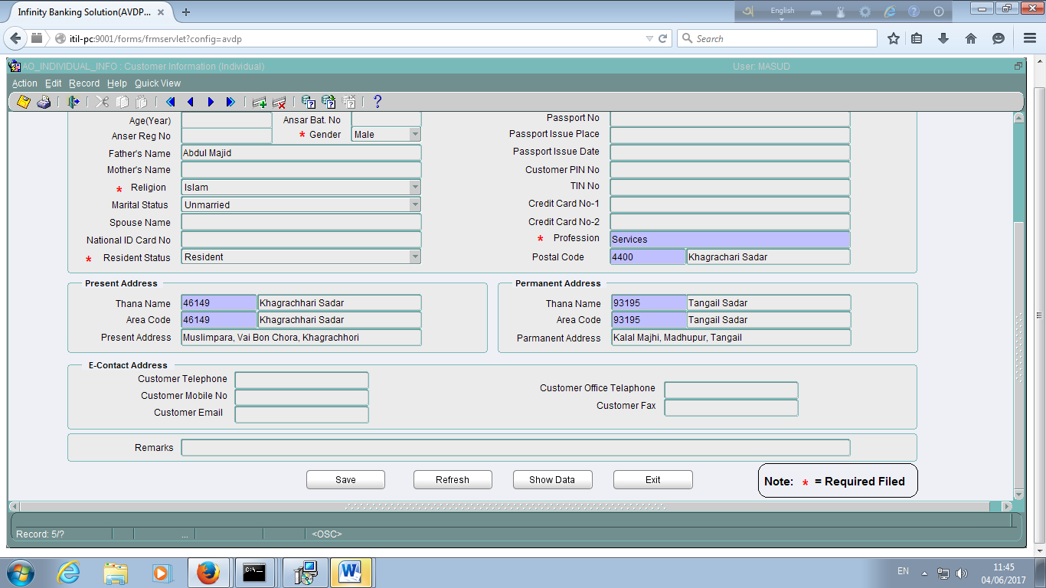

1. Customer Information (Organization)

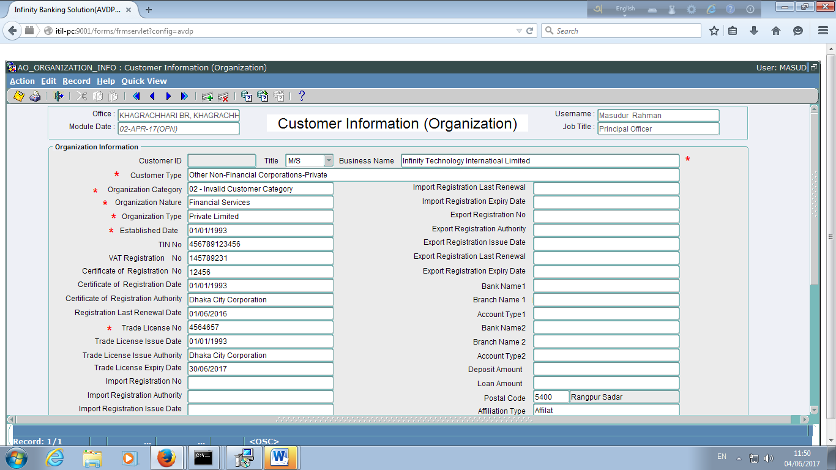

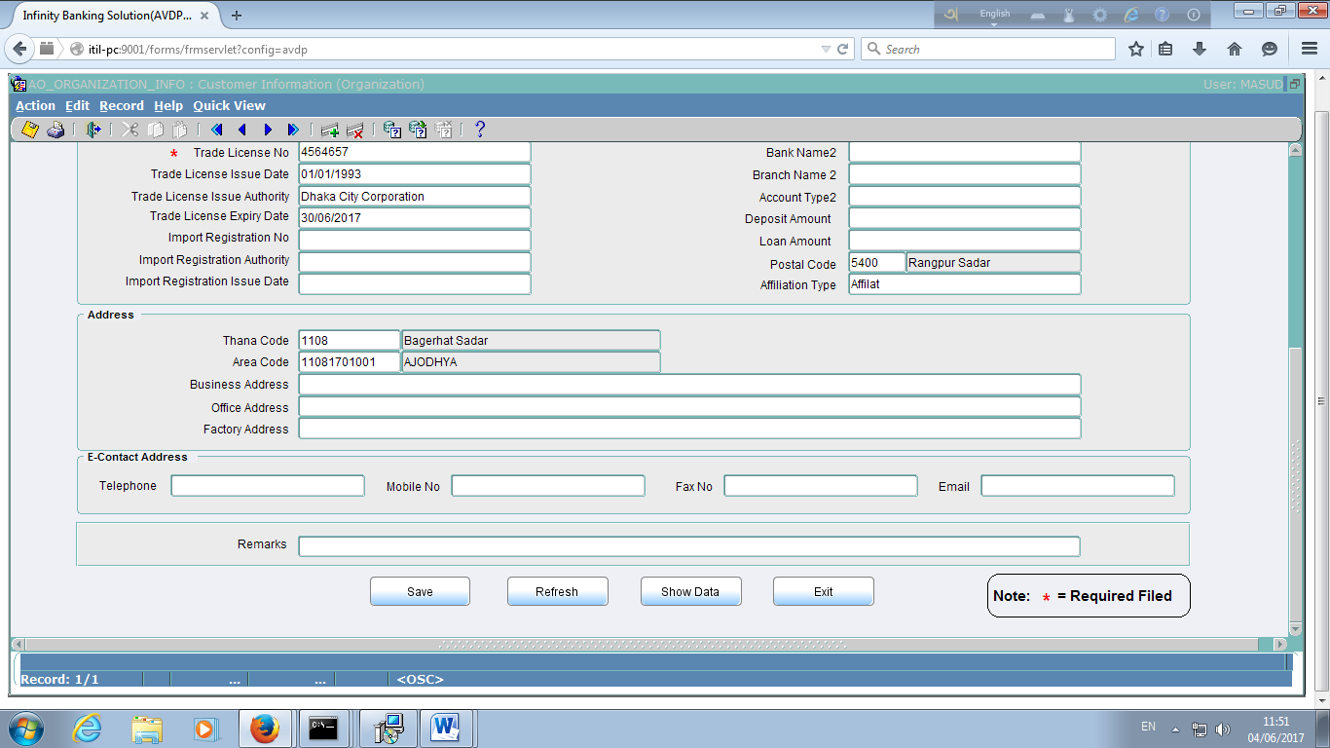

1. Account Open :
   1. Demand Deposit (Savings, Current, SND)

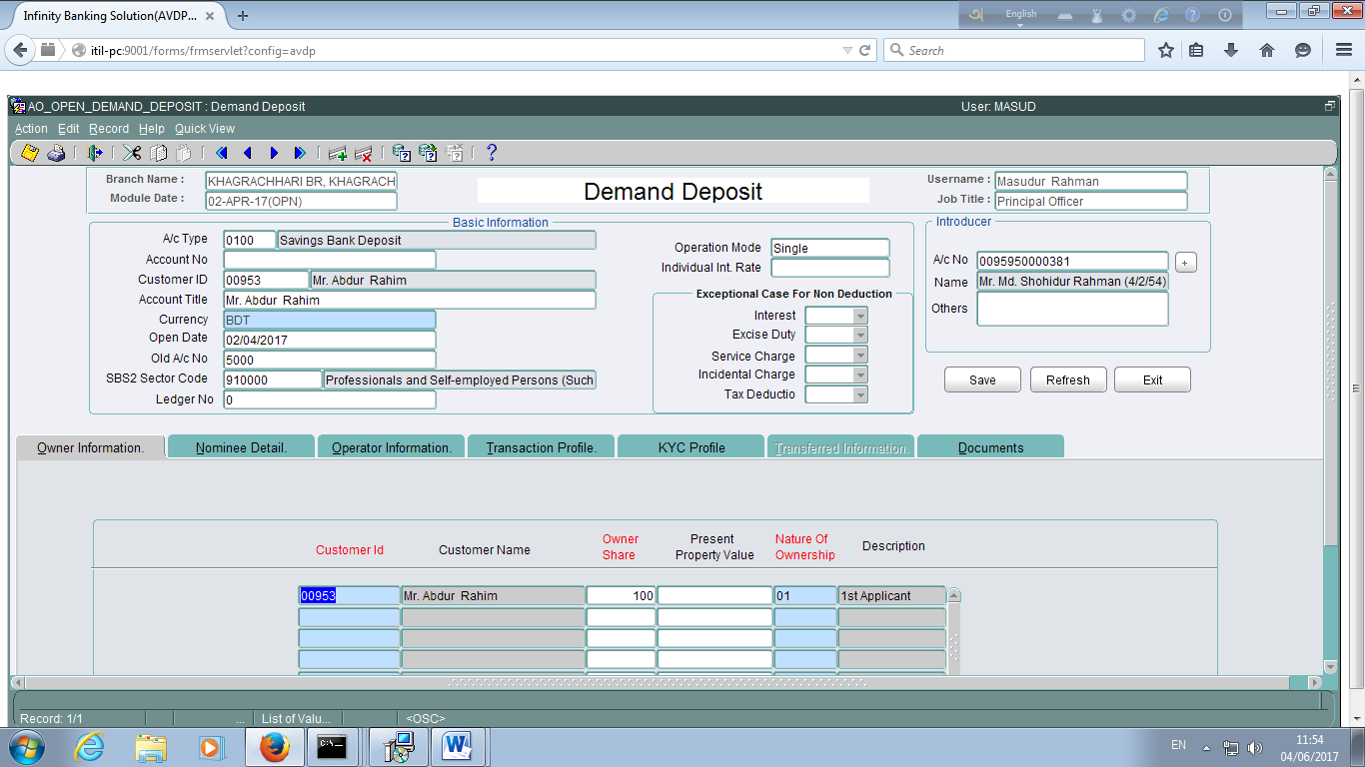

3.1 Nominee Detail

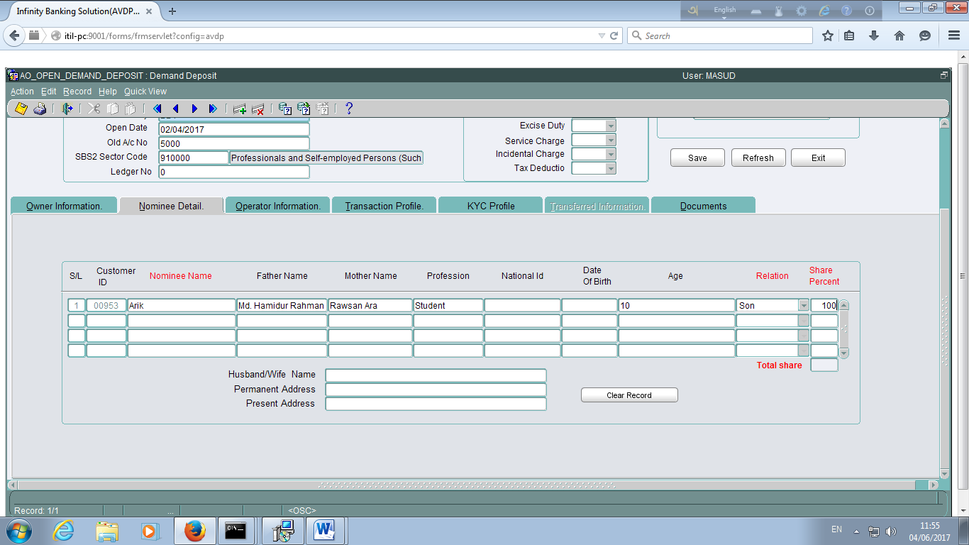

3.1 Operator Information

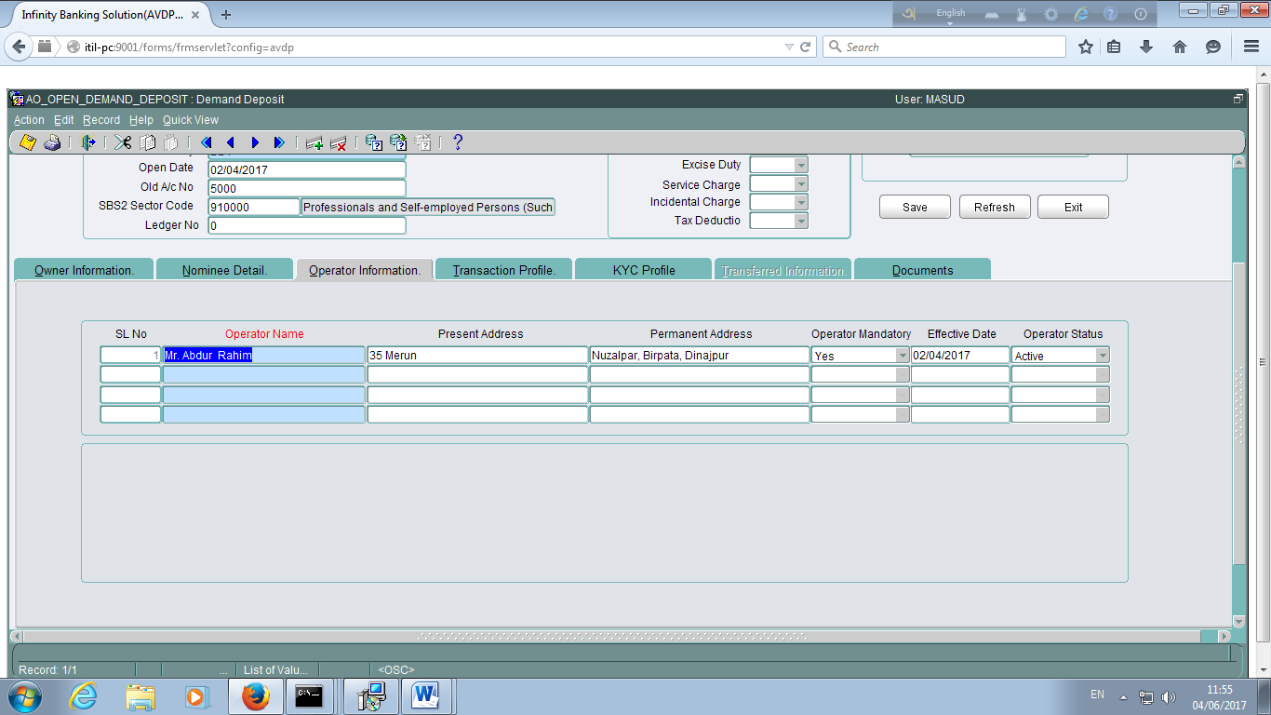

3.1 Transaction Profile

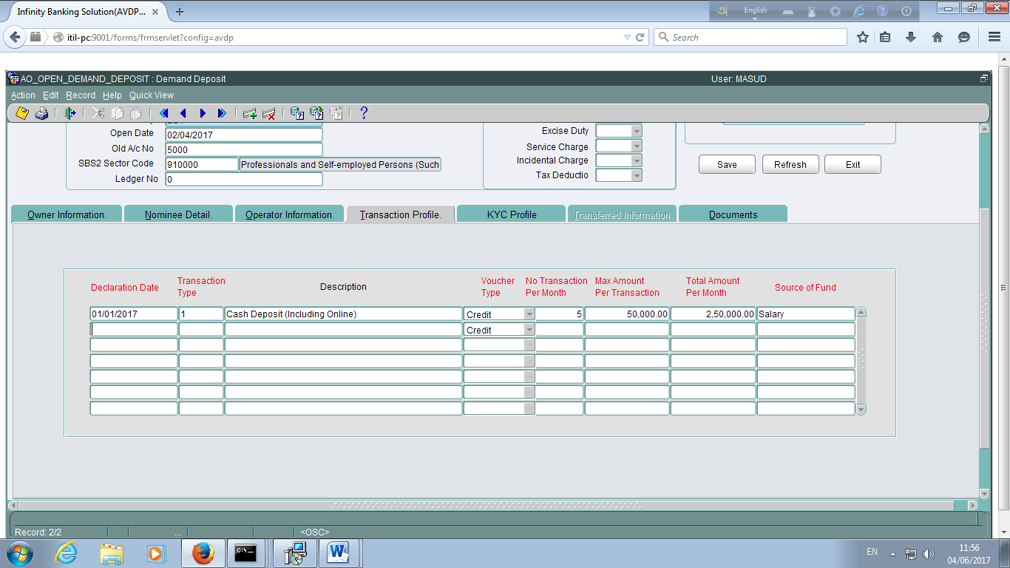

3.1 KYC Profile

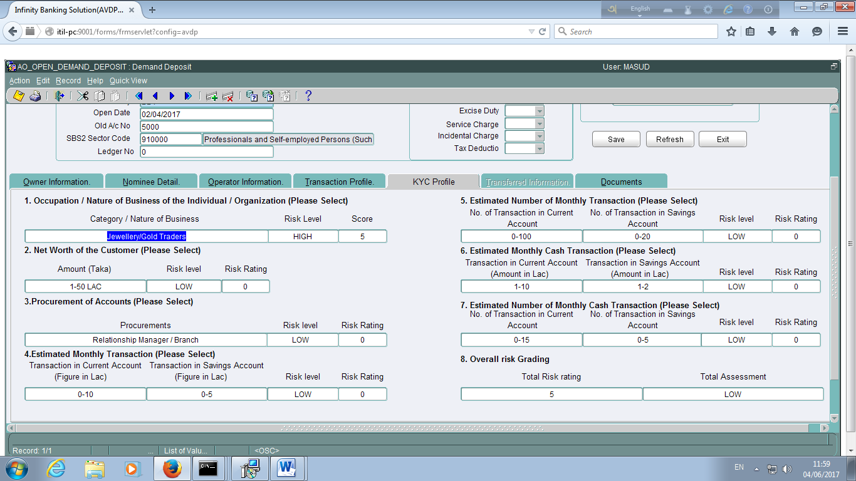

3.1 Documents

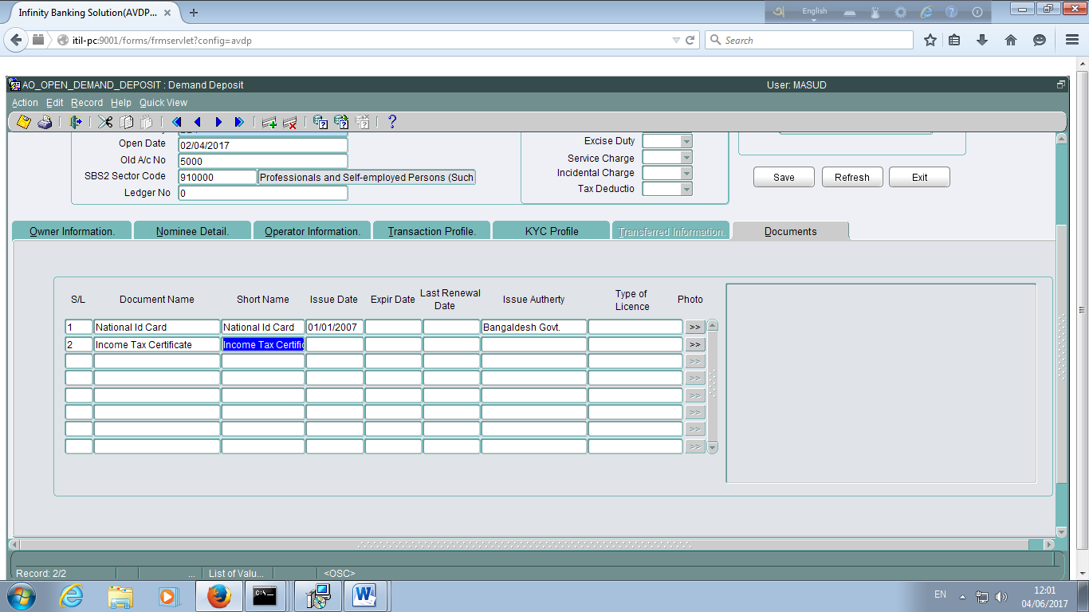

3.2 Account Open Recurring Deposit (Pension Scheme)

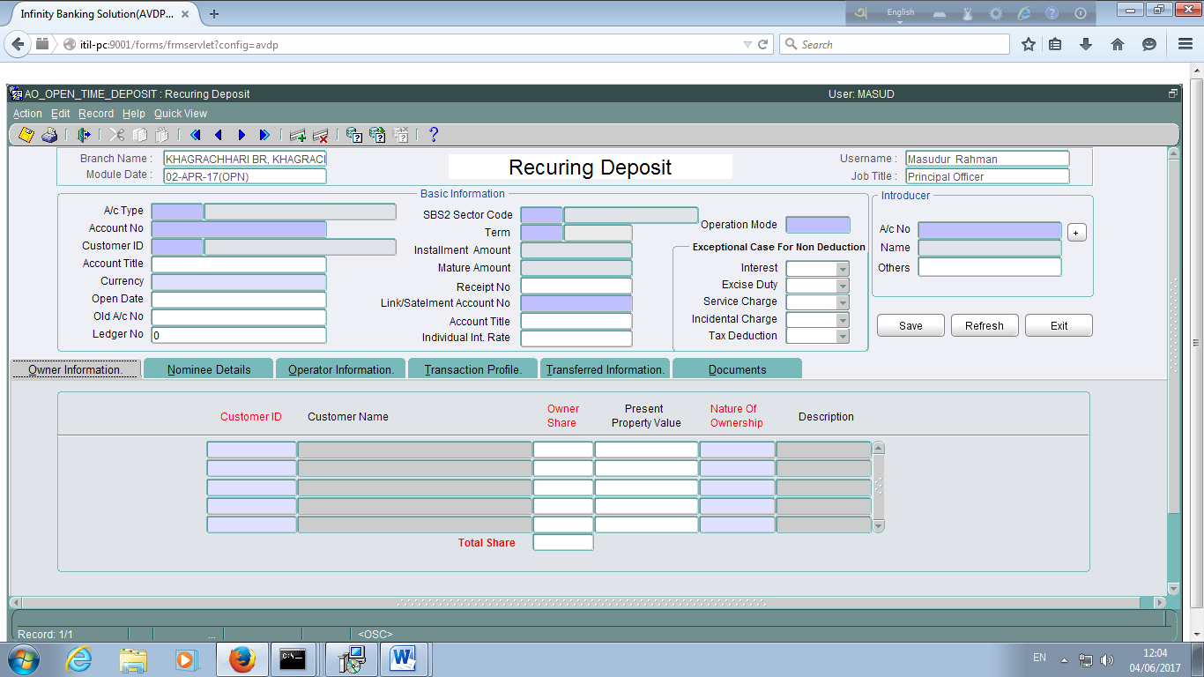

Note: All other information as like Demand Deposit.

3.3 Account Open Recurring Deposit (Fixed Deposit)

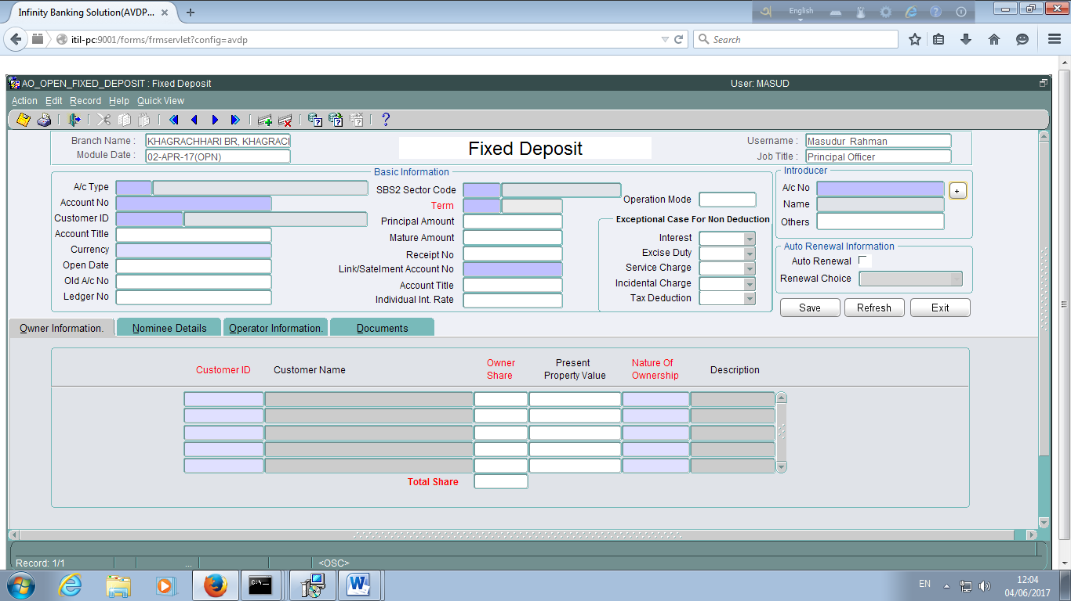

Note: All other information as like Demand Deposit.

3.4 Loan Account Open (Loan/Credit Card)

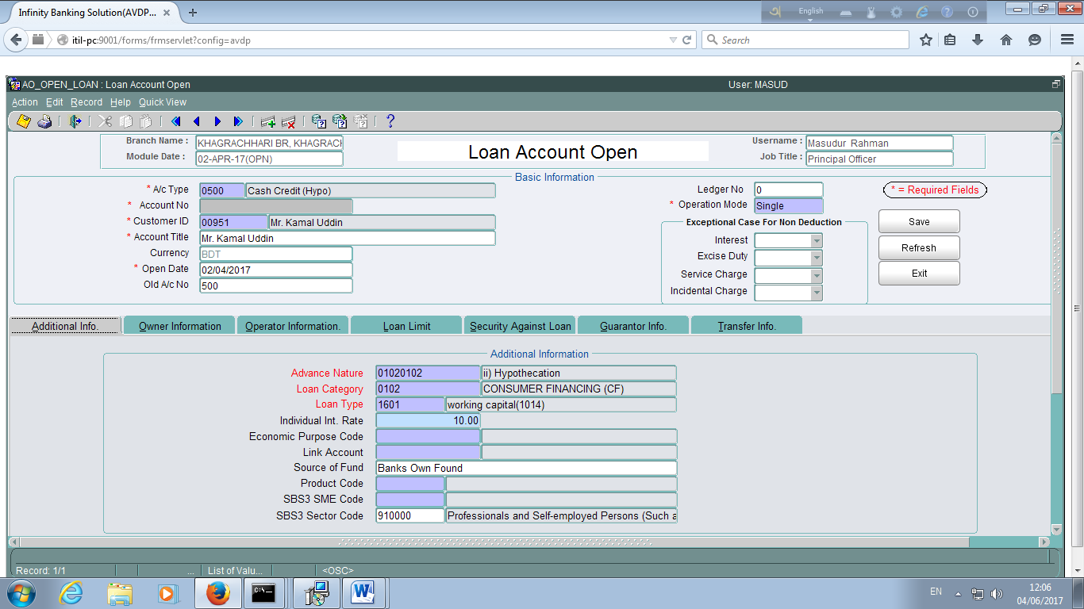

Note: All other information as like Demand Deposit.

3.4 Loan Limit

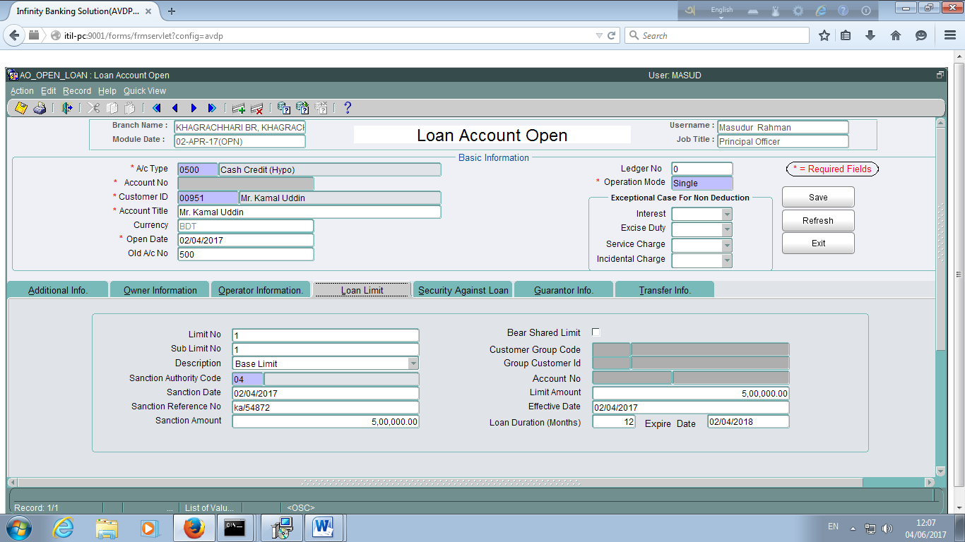

3.4 Security against Loan

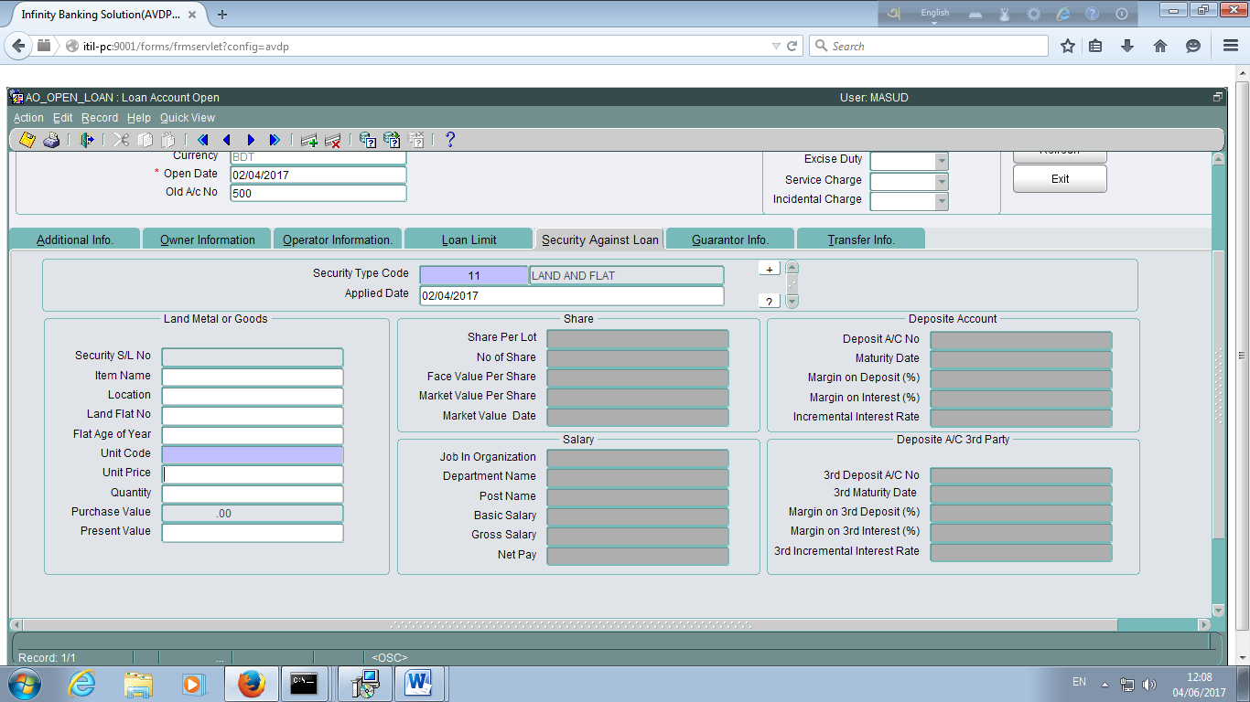

3.4 Guarantor Information

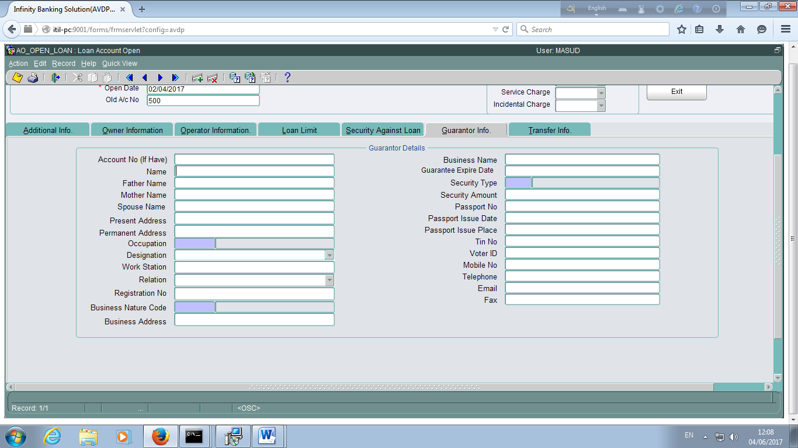

3.4 Godown Information

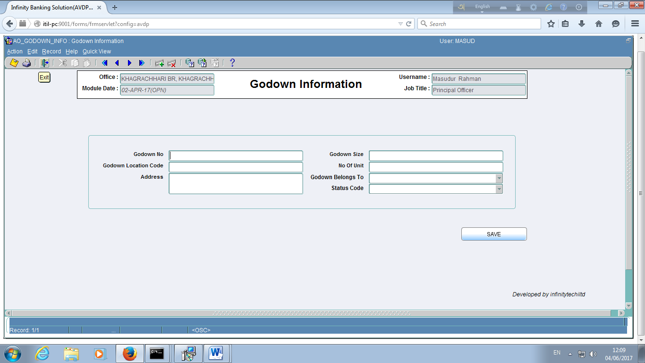

3.4 Goods Information

